READ
TIP
The main idea expresses a particular thought or idea about the topic of a text Details give more information to better explain the main idea. Details may be explanations, examples, reasons, comparisons, or descriptions.
For more about identifying main ideas and supporting details, see Business and Design, Part 1, Skills 1 and 2, pages 31 and 36.
Skim Paragraphs 1-3. Look at the title and the image. Use the hierarchy diagram that follows to write the topic and main ideas. Then read the passage, annotate, add details to the diagram, and answer the questions in Check What You've Learned.

So What Is a Business Model?
by Juli Sherry
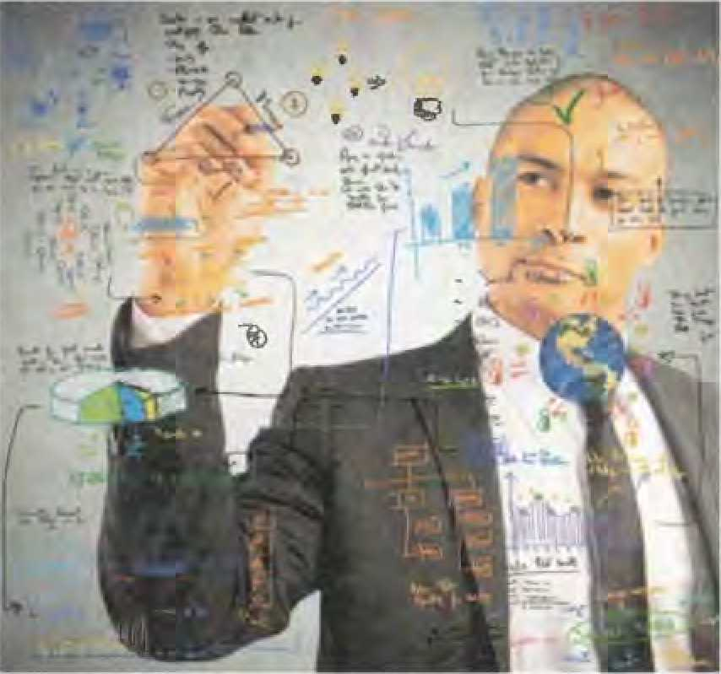
1 A business model, at its very essence, is a set of assumptions that ultimately lead to a representation of what your business does and how it makes money. It is how the inputs (investments you make in your business and its activities) create the outputs (value for the customers you serve). A business model describes the big picture and component parts of what makes your business run and succeed. It represents the choices you make about who your customers are, what product you will create to bring them value, and how you will produce and distribute your product. All of these choices are related. For example, if you decide to create a luxury product, you will probably need to provide a high level of customer service because your customers will expect it. Or if you decide to start a delivery-service business, you will have to hire logistics professionals to make it run efficiently.
- A business model is a tool you can use to help build a business from scratch or a framework to evaluate how your business works today and how you can assure it continues into the future. While a business model is part of an overall business strategy, it does not take the place of one. It typically does not consider the external forces in the marketplace. That is something a good strategy assesses. A business model is used and designed to understand the operations of a business and the reason behind how it creates value. You can think of a business model as a way to tactically execute a larger business strategy.
- Describing a business model can be tricky because there are many ways to approach designing one and communicating it to others. These experts define it simply and elegantly: “Management writer Joan Magretta defined a business model as ‘the story that explains how an enterprise works,’ harking back to Peter Drucker, who described it as the answer to the questions: Who is your customer, what does the customer value, and how do you deliver value at an appropriate cost?” (Casadesus-Masanell / Ricart) While these definitions can be worthwhile to explore and help us to realize the importance of having a business model and being able to communicate it, it is useful to break a business model down into its component parts in order to begin designing one.
CULTURE NOTE
Peter Drucker (1909-2005) was an Austrian-born, American business consultant, writer, and professor. His writings are credited with contributing to the principles of the modern business corporation and its management.
Glossary
Assumption: an understanding that something is true, but without proof
Logistics; the daily steps in making a business work
Efficiently; using time or money well without waste
From scratch: from nothing
Framework; a set of ideas or rules to guide a business
Evaluate: to judge the value of something
Enterprise: an organization or business
Component: a small part of a whole
Paragraph 1: Main Idea:
Major Details:

Minor Details:

TOPIC
Paragraph 2: Main Idea:
Major Details:

Minor Details:
Major Details:
Paragraph 3: Main Idea:
Minor Details;
CHECK WHAT YOU'VE LEARNED
PARAGRAPHS 1-3
- Think about the section you just read and refer to your notes. Answer these questions.
- What do you think is the main purpose of the essay?
- to evaluate the effectiveness of a business plan
- to give the definition of a business model
- to compare a business model to a business strategy
- to analyze how to design a business model by studying its parts
- What is NOT an example of an input?
- providing excellent service to customers
- hiring administrative help
- renting or buying office space
- attending professional development conferences
- The relationship between a business model and a business strategy is the model shows how to the strategy.
- evaluate
- put into practice
- replace
- outline
- Why does the author cite Magretta, Drucker, and Casadesus-Masanell / Ricart?
- to persuade the reader of her expertise on the subject
- to explain a business strategy
- to provide a definition of a business model
- to give credit to the creators of the business model
- Read the section again. Check your answers and add details to your notes.
Then continue to the next section.
"SO WHAT IS A BUSINESS MODEL?" CONTINUED

PARAGRAPHS A-6
Read, annotate, and use a hierarchy diagram or other organizer to take notes.

TIP
Create your own graphic organizer or find one online by searching for "graphic organizer" or a specific kind, such as "hierarchy diagram."
PART

Business Model Components
- There are many tools available that can help yen describe your business model. Some use fill-in-the-blank paragraphs. Others use wnting-based exercises. But the best representations tend to be visual. The most popular of the visual-representation tools for business model design is the Business Model Canvas, created by Alex Osterwalder. This tool allows the user to quickly show and tell the different parts of the model and how they are interrelated. The concrete nature of quickly visualizing ideas helps to make this tool easy to share with others, and the layout helps signify the relationships and necessity of all the components.
- The Business Model Canvas was created by analyzing the many definitions of business models and synthesizing them down to their essence. After years of research while completing a PhD in management information systems, Osterwalder and his advisor discovered, through testing with entrepreneurs, that a visual representation worked best. So he created a map of the nine components he had distilled from his research. (Greenwald) They are as fallows:
Customer Customer
Key
Key Partners . . r. Value Proposition
Activities
Key Resources
Cost Structure
Relationships Segments
Channels
Revenue Streams
- It should be noted that each component is located near the other components that are related to it. While developing an idea or hypothesis about one component, you can see which other components whll likely be affected just by noting its location on the layout. All of the externally facing components are on the right side of the map while all of the internally facing components are on the left. Having all of the parts of your business in your visual field helps you to quickly notice the effects of your design decisions.
(Continued)

Value Proposition
The value proposition is the heart of the business model. It answers the question, “What does your customer segment need?” or “What problem are you solving in the world?”
Customer Segments
Your choice about customer segments is directly related to your value proposition. It answers the question, “Who are you solving a problem for?” This can be one group of people or a few.
Customer Relationships
This is how you communicate with your customers. It’s related to who your customers are and how much assistance they expect throughout the product experience. It can range from high-touch (in-person consulting) to low-touch (automated order-taking and shipping).

Channels
Channels are your choices about how to reach new and existing customers and market your oflering. Different ideas about advertising and selling would fall into this component.
Key Activities
These are choices about how to create your product and other necessities needed to run your business. Some examples are outsourcing, internal production, and equipment maintenance.
Key Resources
This component includes choices about supply chain and where you will acquire what you need to create your product. This includes human resources especially if you are creating a service-based business.
Key Partners
This component describes who you may need to partner with in order to bring your product to market.

Cost Structure
Will you compete with a low-cost product or a high-cost product? You will have to make a choice about pricing and relate it to your customer's price sensitivity. Your cost structure is directly related to the next component, revenue streams.

Revenue Streams
How will you make money? You can make choices to have multiple revenue streams or just one. It will depend on what your value proposition is and how many customer groups you are serving as well as your internal resources.
CULTURE NOTE
Management information systems is the study of the relationships between people, technology, and organizations, Students with a degree in MIS will be able to use information systems to collect and analyze data that is useful internally for a business.
Glossary
Tool: a resource useful for doing your job
Interrelated: related to one another
Concrete: (adj) definite and clear
Entrepreneur; a person who starts a new business
Externally: out, outside
Internally: within, inside
Outsourcing: sending work outside of a company, to another company
Supply chain: the series of organizations that are involved in passing products from manufacturers to the public
Acquire: to get something, especially by buying it
Human resources; in a company, the department that deals with employing, training, and hiring people; abbreviated as HR

CHECK WHAT YOU'VE LEARNED

PARAGRAPHS 4-6
- Think about the section you just read and refer to your notes.
Answer these questions.
- What does the author believe is the best tool to help explain a business model and why?
- How did Osterwalder come up with his nine components in a business model?
- What is the difference between externally facing components and internally facing components?
- Why is a value proposition the heart of the business model?
- Which component do decisions about hiring employees fit into?
- Read the section again. Check your answers and add details to your notes. Then continue to the next section.

"SO WHAT IS A BUSINESS MODEL?" CONTINUED

PARAGRAPHS 7-lZ
Read, annotate, and use a hierarchy diagram or other organizer to take notes.

Target Corporation’s Business Model
- Now that you have an. understanding about the different components of a business model and hotv they are generally related to one another, let’s dive into an example: low-cost retail. How would this traditional model he described using the Business Model Canvas framework? Let’s look at an example of a business using the low-cost retail model: Target Corporation.
- The first two components to work with are Value Proposition and Customer Segments. Target’s value proposition is, “We fulfill the needs and fuel the potential of our guests ,.. [through] continuous innoc^tion and exceptional experiences—consistently fulfilling our Expect More. Pay Less.® brand promise.” (“Purpose & Beliefs”) This can be simplified by saying that Target meets its customers’ needs by offering a large assortment of low-cost everyday products with a high standard of design. Target’s typical customer persona is described as a year olc female who is likely to have children, with a median household income of $63,000, who has attended college. (“Target Corporation”) An easier-to-manage description of this customer persona is a “minivan mom.” So the heart of Target’s business model (Value Proposition + Customer Segments) is providing low-cost, high-design utilitarian products of a large assortment to minivan moms across the US.
- In order to provide this value to customers, Target has a lot of work to do. Target has made choices about its channels, which are an assortment of brick and mortar stores as well as an online marketplace. It also spends on advertising through print ads in daily newspapers and TV commercials, as well as online ads and billboards. In terms of customer relationships, Target provides mid-level customer service within stores through store employees. Target is not completely hands off but is not high-touch like a boutique or customized luxury brand.
- The internally-facing components of its model (Key Activities, Key Partners, and Key Resources) are chosen with the intent to deliver its product at the cost and service level described previously. Target has many distribution centers across the US to keep its stores stocked efficiently. This is one of Target’s key activities—distribution. It has some “house brands” that it manufactures internally and distributes through its stores, but Target’s main activity is sourcing products and working with many manufacturers to find products that meet customers’ expectations. Target also makes its store experience pleasant and maintains the real estate that it owns.
- The key resources Target needs to keep the business running are its employees, logistics systems, computer equipment, shipping, and real estate. Key partners for Target are the manufacturers it purchases its products from, and its produce partners (it doesn’t use its own distribution for perishable products). This helps keep costs down by not having to invest in more infrastructure. Target also has many other partners such as architects and advertising firms that it works with to manage its variable resources,
- Target’s cost system is based on ah of these activities. It keeps costs low by being efficient at sourcing products and negotiating with manufacturers. It also makes larger profits by selling gift cards and dominating the gift card market. Target’s revenue streams come directly from selling physical products but also through a few other outlets like its sourcing services and financial and retail services that were created to manage its REDcard® finance offering.
CULTURE NOTE
Target, first started by George Draper Dayton and known as Dayton Dry Goods Company in Minnesota, US, has been in the retail business since 1902. In 1962, st was renamed Target with the goal of offering retail goods at a good price, with good service and a commitment to the community. At that point, the butt's-eye logo, which is still synonymous with its name, was developed, From those days, Target has grown and now has over 1,800 stores in the United States with 323,000 employees.
Glossary
Retail; the sale of products from a store
Innovation; the creation of something new; new ideas
Median household income: average amount of money that the people in one house earns in one year
Minivan: a box-shaped automobile with seats for six to eight people
Utilitarian: practical, but maybe not attractive
Brick and mortar store: a business with a physical store, not online
Hands off: giving people freedom to make their own decisions
Source: (v) to find materials or other resources
Produce: (n) fruits and vegetables
Perishable: not lasting, becoming rotten after some time infrastructure: the basic system a business needs to function
CHECK WHAT YOU'VE LEARNED
PARAGRAPHS 7-12
- Think about the section you just read and refer to your notes. Answer these questions.
- From the description of a “minivan mom” in Paragraph 8, you can infer that Target’s typical customer
- is employed
- owns a small automobile
- cares about pricing
- is divorced
- In Paragraph 9, Sentence 2, channels most likely means
- TV networks that Target advertises on
TIP
Inferences are educated guesses made from facts, observations, and logic. Inferencingis usmg what you know about a text to understand information not directly stated. Predicting is when you use the facts and ideas in a text, as well as your inferences, to make a guess about what wilt come next.
For more about making inferences and predictions, see Business and Design, Part Z, Skills 1 and 2, pages 171 and 176.
- Target’s employees
- the prices of Target’s products
- the places where Target’s products are sold
- From Paragraph 10, you can infer that
- most of Target’s products are manufactured by outside companies
- Target is responsible for manufacturing the majority of its products
- distribution is not a major part of Target’s key activities
- Target does not consider the interior design of its stores to be important
- From the information in Paragraph 11, you can infer that
- someone shopping at Target could buy food as well as other household goods
- Target’s business model is poorly designed
- Target needs to cut its distribution costs
- Target does too much advertising
- What is an example of how Target keeps costs low?
- It hires the best employees and offer great benefits.
- It negotiates prices with the manufacturers of its products.
- It purchases updated equipment on a regular basis.
- It makes its stores a visually pleasing place to shop.
- Read the section again. Check your answers and add details to your notes. Then continue to the next section.

"SO WHAT IS A BUSINESS MODEL?" CONTINUED PARAGRAPHS 13-16
Read and use your organizer to take notes.

Iterating to Create a Business Model That Works
- A best practice if you are creating a new business is to use the business model framework to manage your assumptions about how your business could work. By going through this thought experiment and iterating on your ideas for each component, you can build a business model that works.
- The best way to start is to sit down with the Canvas and sketch out what choices you would make for each component. Then compare each choice you make with the other components to test if it is logically sound. Once you have a draft, you can start to test your assumptions by building experiments around each component. For example, if you believe that your customer segment—college students—has a need to acquire course books faster, you can meet with college students and ask them about their experience buying books for their classes. If that assumption holds true and they have a need for faster acquisition of books, then you can start to take orders for next-day delivery. Through this test you will learn the key activities and resources you will have to partake in to meet the college student need that you have discovered.
- Once you verify your assumptions about value proposition and customer segment, you can experiment with a cost structure, such as having students pay in advance or on delivery of their books. If one of your assumptions doesn’t hold true, it is appropriate to try out another approach and to think through the effect it will have on the other parts of your business. Once you have worked through ail of the components and tested and verified your assumptions for each, you have created a working business model. While building your business, your model will evolve and become stronger as you grow and try different ideas. Because business models are never quite done, it’s important to always be thinking about each component and how it can be changed or improved to meet the changing needs of your customers,
- There is never one “right” business model. A business model is always changing and being innovated upon. But there are great tools out there to help you manage and understand what your business model is and how to continually improve it.
Sources
- Casadesus-Masanelt Ramon, and Ricart, Joan E "How to Design a Winning Business Model." Harvard Business Review. N.p., 07 Oct 2014. Web. 31 Mar. 2017.
Glossary
Iterate; to repeat or do again
Best practice: a good rule or behavior that a business follows
Acquisition; receipt of something
Partake: to participate in
Verify; to decide if something is true Evolve: to change slowly over time
- Osterwalder; Alex. "Strategyzer; Business Model Canvas." Strategyzer; Business Mcxiei Canvas. N.p., n.d. Web. 31 Mar. 2017.
- Greenwald, Ted. "Business Model Canvas: A Simple Tool For Designing Innovative Business Models." Forbes. Forbes Magazine, 31 Jan. 2012. Web. 31 Mar. 2017.
- "Purpose & Beliefs." Target Corporate. N.p., n.d. Web. 31 Mar. 2017.
- 'Target Corporation," Wikipedia. Wikimedia Foundation, 28 Mar. 2017, Web, 31 Mar. 2017.
CHECK WHAT YOU'VE LEARNED
PARAGRAPHS 13-16
A. Think about the section you just read and refer to your notes.
Answer these questions.
- In Paragraph 14, why does the author give an example of a college student who has a need for the faster acquisition of books?
- In Paragraph 15, the author writes that “While building your business, your model will evolve and become stronger as you grow and try different ideas,” What can you infer about what those different ideas might be? Why do you think the essay doesn’t list specific ideas?
- The final paragraph of the essay says, “There is never one ‘right’ business model. A business model is always changing and being innovated upon. But there are great tools out there to help you manage and understand what your business model is and to continually improve it.” What inferences about creating a business model can you draw from this information?
- What is the main idea of the essay? Use your own words. Does the title state the main idea? If so, how? If not, what would be a better title?
B, Read the section again. Check your answers and add details to your notes.
C. Using your notes, write a 100-word summary of the essay. Try to use the words from the box.
business model component customer evaluate framework product tool

THINKING CRITICALLY
Look back at your notes and answers in Check What You've Learned, Answer the questions.
- Peter Drucker explains that a business model is the answer to “Who is your customer, what does the customer value, and how do you deliver value at an appropriate cost?” How does Drucker’s explanation relate to the Business Model Canvas?
- Think about what it takes to start and run a business. Do you think it’s necessary for all businesses to have a business model? Why? Explain,
- What advice would you give someone planning to create a business model?
О Go to MyEnglishLab to complete a critical thinking activity.

THINKING VISUALLY
A. Look at the Business Model Canvas for Target. From the information, what can you infer about Target?
Key Partners | Key Activities | Value Proposition | Customer Relationships | Customer  Segments
Manufacturers | • | • “We fulfill the needs | * Provide mid | • a 41-year-old
Target purchases |  | and fuel the potential of | level customer | female who
its products from, |  | our guests ... [through] | service within | is likely to
and its produce |  | continuous innovation and | Target’s stores | have children,
partners |  | exceptional experiences— consistently fulfilling our Expect More. Pay Less.® brand promise.” (“Purpose & Beliefs.”) Author’s paraphrase; Target meets customers’ needs by offering a large assortment of low-cost everyday products with a high standard of design. | through store employees | with a median household income of $63,О(Ю, who has attended college (“Target Corporation”) Author’s paraphrase: “minivan mom”
Key Resources
Channels

Revenue Streams
Cost Structure
• Come directly from selling physical products but also through Target’s sourcing services and financial and retail services created to manage Target’s REDcard® finance offering
B. Using your notes, complete the Business Model Canvas about Target. Compare Canvases with a partner.

